WH1427
Thermostat and timing Product Manual

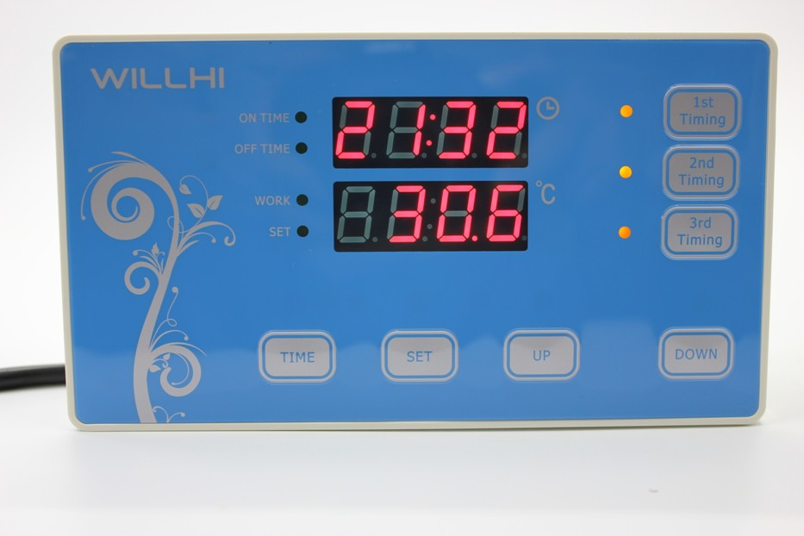

Shenzhen Willhi Electronics Co., Ltd.
Tel :0755 -29539385 Fax :86-0755 -2953 9395
Technical support: Engineer Tian

① Installation opening size:
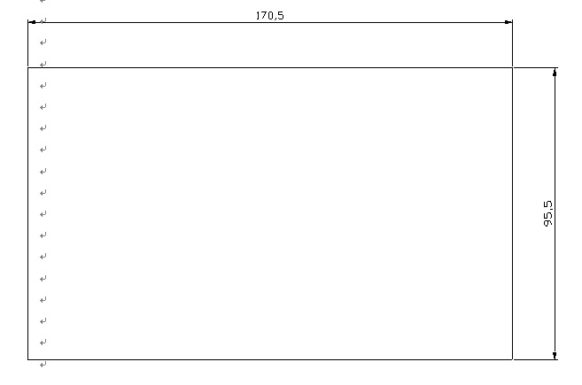
Thermostat Controlle
◆LED Status Description:
The WORK light is used as working indicator lights, flashing is to indicate the delay of cooling or heating, if the LED is always on, it indicates it is on the status of cooling or heating .
The SET light is used as setting indicator lights, if the LED is always on, it indicates it is on the status of setting.
◆Turn on or off the thermostat:
When it is wired up, the state of being acquiescent is power on.
Press” TIME” key to switch on and off, press the “TIME” key once on the power-off state to turn it on. On the power-on state, press the” TIME” key and hold on for three seconds, then it will be off.
◆temperature control setting：
In the Standby mode, press the SET key once to enter the temperature control setting, press UP or DOWN button to adjust, press UP or DOWN button and hold on for three seconds to enter the fast adjusting mode, press the SET key again and back to the standby mode.

◆system menu settings：
Press SET and UP key and hold on for 3 seconds to enter the controlled- parameters setting, press the UP or DOWN key to select the adjustment menu, press SET key once to enter the appropriate parameter settings, press UP or DOWN to adjust the parameters needed to be modified. After being adjusted, press the RST key to exit, or exit as the system delay for 5 seconds.
◆ Menu code statement:
Symbol | Details | Remark
HC | Heating / cooling | H= Heating C= cooling
D | Hysteresis
LS | The minimum set limit
HS | The maximum set limit
CA | Temperature calibration
PT | Delay time | Minutes
AH | High temperature alarm settings
AL | low temperature alarm settings

◆Cooling, heating function:
Cooling Mode: When the measured temperature is higher than or equal to the set value + hysteresis, the relay picks up to start the output; When the measured temperature below the set value, the relay off and close the output.
Heating mode: When the measured temperature is higher than or equal to the set value, the relay off, turn off the output; When the measured temperature below the set value - hysteresis, the relay picks up to start the output.

Example for Setting: If it is set to heating mode, set the temperature to 25 degrees, hysteresis is set to 5, then when the measured temperature is higher than or equal to 25 degrees, the relay is off, close the output. When the temperature is below 20 degrees, pick up the relay again, to start the output.
Example for Setting: If it is set to cooling mode, set the temperature to 25 degrees, hysteresis is set to 5, then when the measured temperature is below 25 degrees, the relay is off, close the output. When the temperature is higher than or equal to 30 degrees, pick up the relay again, to start the output.
◆ Cooling, heating mode setting:
Press SET and UP key and hold more than 3 seconds to enter the menu display, the screen appears "HC" code, press the "SET" key to display the working mode, press the "UP" or "DOWN" to adjust the display, C means cooling mode; H means heating mode.
◆ Hysteresis function:
Hysteresis setting limits the maximum interval between the opening and stopping.
◆ Hysteresis settings:
Press SET and UP key and hold more than 3 seconds to enter the menu display, with "UP" or "DOWN" key adjusted to the screen, appearing "D" code, press the "SET" key to display the hysteresis set value, press "UP "Or"DOWN"key to adjust the parameters.
◆ Temperature calibration function:
When there is deviation between the measuring temperature and standard temperature, use the temperature calibration function, make the machine measurements value consistent with the standard temperature, the after calibration temperature= the before calibration temperature + calibration value (calibration value can be positive number, negative number, and 0) .
◆ Temperature calibration settings:
Press SET and UP key and hold more than 3 seconds to enter the menu display, with "UP" or "DOWN" key adjusted to the screen, appearing "CA" code, press the "SET" key to display the temperature calibration settings, press "UP "Or"DOWN"key to adjust the parameters.

For example: When we measure the probe temperature was 25 degrees, it displays 25 degrees as the CA is 0, it displays 26 degrees as the CA is 1, it displays 24 degrees as the CA is -1. This function is generally applied when the probe can not measure directly the measured object. For example, we place the probe at the outside of a cup to measure its water temperature, we need to adjust the CA parameters because of the heat loss of the cup, so that the display temperature can be in accordance with the one of the cup.

◆ Delay Protection Function:
In the cooling mode, the first power on, when the measured value above the set value + hysteresis value, the machine will not immediately start cooling, it needs to set the delay time, then the machine can run to start cooling; once the interval between two cooling is larger than the delay time, the machine immediately starts cooling, once the interval between two cooling is less than the delay time, the machine must run the remaining delay time to start cooling. The delay time is started to calculate from stopping the machine. The delay time of heating mode is as same as the cooling mode.
Note: It is recommended that only the device that use compressor cooling can use the delay start function, the user who don't need delay start function please set this parameter to 0.
◆ Delay Protection Setting:
Press SET and UP key and hold more than 3 seconds to enter the menu display, with "UP" or "DOWN" key adjusted to the screen, appearing "PT" code, press the "SET" key to display the delay setting value, then press the "UP "or "DOWN"key to adjust the parameters.
◆ Upper and lower limit functions:
The setting of HS and LS limit the set range of control temperature point , for example: HS is set to +15, LS is set to -10, the control temperature can only be adjusted between -10 and +15, when the control temperature to -10 then press "DOWN" key, the display will remain on the status of -10 and not decrease; when the control temperature to +15 then press "UP" key, the display will on the status of 15 and not increase. If the set point outside this range, it needs to firstly change the value of HS and LS, then it can be achieved.
◆Upper and lower limit settings:
Press SET and UP key and hold more than 3 seconds to enter the menu display, with "UP" or "DOWN" key adjusted to the screen, appearing "HS" or "LS" code, press the "SET" key to display the upper or lower limit set value, Then press "UP" or "DOWN" key to adjust the parameters. HS means upper limit. LS means lower limit.
◆High temperature alarm:
If the measured temperature≥ set temperature + AH alarm output relay. Thermostat alarm will sound, the display alternately shows H and the current temperature. Alarm, press any key to stop the alarm and relay output.
◆ High temperature alarm settings:
Press SET and UP key and hold more than 3 seconds to enter the menu display, with "UP" or "DOWN" button transferred to the screen appears "AH" code, press the "SET" key to display the high-temperature alarm settings, press "UP "or" DOWN "key to adjust the parameters
◆ Low temperature alarm function:
If the measured temperature ＜set temperature-AL when the alarm output relay. Thermostat alarm will sound, the display alternately shows L and the current temperature. Alarm, press any key to stop the alarm and relay output.
◆ low temperature alarm settings:
Press SET and UP key and hold more than 3 seconds to enter the menu display, with "UP" or "DOWN" button transferred to the screen appears "AL" code, press the "SET" key to display the low temperature alarm settings, press "UP "or" DOWN "key to adjust the parameters

⑥ Errors indications:
1) When the sensor disconnected, the screen displays EEE ,
2) When the sensor detects the temperature is below the lowest temperature that could be detected, the screen displays LLL.
3) When the sensor detects a temperature higher than the Maximum temperature that could be detected, the screen displays HHH.

Time controlling:
The equipment has a backup battery, when the external power supply is disconnected, the system will automatically update the time, the user do not need to re-set.
The Internal Battery’s life is about 5 years and it is replaceable.

Set the current time:
Press the "TIME" button, enter to set the current “hours”, and the “hours” will flashing, press UP or DOWN keys to adjust the “hours”value, after adjusting the current “hours”, press TIME to enter minute setting, press UP or DOWN keys to adjust the “minutes”value, once finish the setting, user can press TIME key to exit

Open and close timing functions:
Press the "1st timing" or "2nd timing" or "3rd timing" button, you can turn on or off the corresponding timer function, the corresponding LED will turn on when the timer is working, and the LED goes off when closed.

Timing duration settings:
Press the "1st timing" button for 3 seconds, enter to set the “ON TIME”, the “ON TIME” LED will light,Press the UP or DOWN keys to adjust the”Hours” value, after finish then press "1st timing" button again to set the “minutes”value, press UP or DOWN keys to adjust the“minutes” value, after finish setting “minutes”, Press ”1st timing” to set the “OFF TIME”, the “OFF TIME” LED will light, press UP or DOWN keys to adjust the “Hours” and “Minutes”value,press "1st timing" key to exit the setting.

The second and third timing setting is the same as the first timing.

⑦ Caution for using:
◆ Please connect the correct operating voltage, the machine normally works under the standard input voltage within range of ± 10%.
◆ The load power should not exceed the maximum thermostat control power, when exceeding please connect external AC contactor.
◆ Please connect the power load correctly and the sensor, or it will damage the thermostat, when connect the wrong line .
◆ Please do not put the sensor lines and power lines in parallel, power line noise affects the accuracy of the measurement.

